**A**

**MINI PROJECT REPORT**

**on**

**POWER SAVING USING APFC**

FOR PARTIAL FULFILLMENT

OF THE REQUIREMENTS FOR THE

Mini PROJECT and SEMINAR SUBJECT

oF T.E. E&TC – 2015 Course, SPPU, Pune

BY

**SHUBHAM KALE 3726**

**RUCHA KHOPKAR 3728**

**KSHITIJ MAHAJAN 3735**

**GUIDE**

**Prof.V.B.Vaijapurkar**



**DEPARTMENT OF ELECTRONICS & TELECOMMUNICATION ENGINEERING**

PUNE INSTITUTE OF COMPUTER TECHNOLOGY

DHANKAWADI, PUNE- 411043

**ACADEMIC YEAR: 2018 - 2019**

**Department of Electronics and Telecommunication Engineering**

**Pune Institute of Computer Technology, Pune – 43**

**CERTIFICATE**

This is to certify that the project report entitled

**“POWER SAVING USING APFC”**

has been successfully completed by

**SHUBHAM KALE 3726**

**RUCHA KHOPKAR 3728**

**KSHITIJ MAHAJAN 3735**

Is a bona fide work carried out by them under the supervision of Prof.V.B.Vaijapurkar and it is approved for the partial fulfillment of the requirements for the Mini Project and Seminar Subject of T.E. E&TC – 2015 Course of the Savitribai Phule Pune University, Pune.

Prof. Prof.Dr.Y.Ravinder

V.B.Vaijapurkar HOD,

E&TC Dept. of E&TC

Place: Pune

Date :

ACKNOWLEDGEMENT

The completion of this project could not have been possible without the participation and assistance of so many people whose names may not all be enumerated. Their contributions are sincerely appreciated and gratefully acknowledged. However, the group would like to express their deep appreciation and indebtedness particularly to the following:

We express a deep sense of gratitude to V.B.Vaijapurkar (Project Guide), Dr. S. Shreemathy and Dr. Y. Ravinder (HoD E&TC) for their valuable guidance, keen interest, constructive criticism and encouragement at various stages in the completion of this project.

Last but not the least, we would like to express our gratitude to our friends and respondents for their support and willingness to be there with us, to share their support, either morally, financially or physically.

Shubham Kale,

Rucha Khopkar,

Kshitij Mahajan.

ABSTRACT

This project is mainly proposed for reducing the power loss in industries by using power factor compensation through a number of shunt capacitors. Power factor is defined as the ratio of real power to apparent power.

So, the increase in reactive power (real power) increases the apparent power , so the power factor also decreases. By having low power factor , the industry needs more energy to meet its demand, so the efficiency decreases.

In this system, we proposed the time lag between zero voltage pulse and zero current pulse delay generated by suitable op-amp circuits in comparator mode and fed into two interrupt pins in microcontroller. Microcontroller displays the power loss due to inductive load on the LCD. This process is continuously actuate until the power loss would be zero by using relays which is used to bring the shunt capacitors into load circuit. 16-bit microcontroller is used in this project which belongs to PIC 18 family.

**CHAPTER 1**

**Introduction**

Aim of the project :

* Study existing techniques being used for power factor measurement and correction.
* Incorporate one of the existing technique.
* Implement and verify for its performance.

Problem Definition:

Design and develop power factor measurement and correction system.

Brief History:

Majority of the loads in the industries are highly inductive in nature such as induction motors, AC/DC drives, welding machines, arc furnaces , fluorescent Lightings, electronic controls and computers. There may be a few resistive loads for heaters and incandescent bulbs. Very rarely industries may have capacitive loads such as synchronous motors.

Net industrial load is highly inductive causing a very poor lagging power factor. If this poor power factor is uncorrected , the industry will require a high maximum demand from Electricity Board and also will suffer a penalty for poor power factor. Standard practice is to connect power capacitors in the power system at appropriate places to compensate the inductive nature of the load.

Recent trends and developments in the field:

Usually, standard practice is to connect the power capacitors in the power system at appropriate places so that the inductive nature of the load can be compensated. So, the power factor is used in this project to reduce the power loss in industries and by using the shunt capacitors.

Power factor is about the ratio of real power to apparent power . So it is mathematically represented as KW/KVA where the numerator is active(real) and denominator is the (active+ reactive) or apparent power. The increase in the reactive power increases the apparent power ,so that power factor also decreases . Having low power factor , the industry needs more energy to meet its demand , so the efficiency is decreases.

Literature Survey:

In earlier days , the power factor correction was done by using the resistive loads which provides the more power loss at the output. In second method , the power factor correction was done by using the capacitive load bank which was done by manual changes but it gives only less amount of increasing in efficiency.

There are also some other complicated methods invented for PF correction which are not much popular for economical purpose and some methods are under research .Phase Advancer ,Three -Phase buck -boost PFC circuit and controlling method etc. are some other under research methods.

One more method is Synchronous Condenser .It is synchronous motor that rotates under no load condition. Asynchronous motor shows capacitive behavior while operating in over-excited mode .By controlling the field excitation power factor can be adjusted continuously .It provides step-less PF correction and not affected by system harmonics. But its installation and maintenance is costly.

**CHAPTER 2**

Block Diagram:

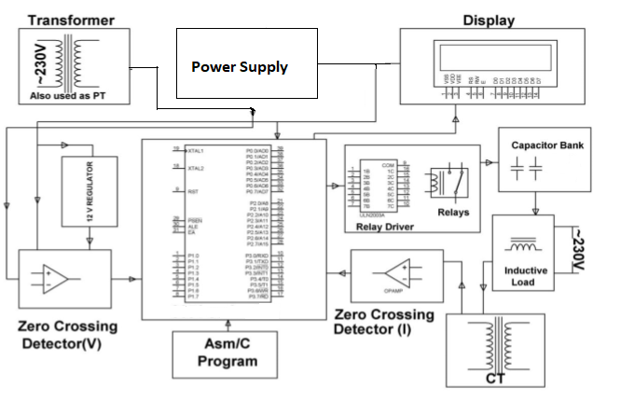

Fig. No. 2.1 Block Diagram .

Requirement of each block:

1.*Potential Transformer*: Transformers convert AC electricity from one voltage to another with a little loss of power. The potential transformer (PT) essentially uses a step-down transformer to reduce the dangerously high voltage to a safer low voltage (typically 110 Volts) in any substation.

2.*Current Transformer*: In an electrical circuit, a current transformer (CT) is used for measurement of electric currents. When current in a circuit is too high to directly apply to measuring instruments, a current transformer produces a reduced current accurately proportional to the current in the circuit, which can be conveniently connected to measuring and recording instruments.

3.*Zero Crossing Detector*: The zero crossing detector is a sine-wave to square-wave converter. To calculate the phase lag between the voltage and current, two detectors are used to find the arrival instance of each signal.

4.*Display Unit*: One of the most common devices attached to the microcontroller is an LCD display. Some of the most common LCDs connected to microcontroller are 16x2 and 20x4 displays.

5.*Microcontroller****:*** It takes input, processes it according to the program written to it and then gives the processed output. It also has some on chip memory which is utilized to store some temporary variables during processing is going on.

6.*Relay unit****:*** This unit consists of a relay driver and some relays. As the output of the microcontroller cannot control the switching of capacitors directly, this unit is responsible for controlling the high power circuit from a low power circuit.

***7.****Capacitor Bank****:*** Shunt capacitor banks are used to improve the quality of the electrical supply and the efficient operation of the power system. Studies show that a flat voltage profile on the system can significantly reduce line losses.

**CHAPTER 3**

Detail design block:

1.Potential Transformer:

As LM324 requires 5 to 12 V to operate ,we are using 230/12 v potential transformer to step down the 230 ac mains supply.

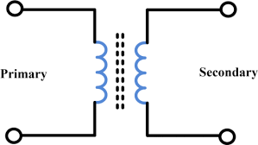

Fig 3.1 Potential transformer.

2.Current Transformer:

Since, we are comparing voltage and current waveforms, we need to sense current wave of ac mains supply. Therefore, we have used current transformer as a sensing element. Maximum o/p current is 5A .

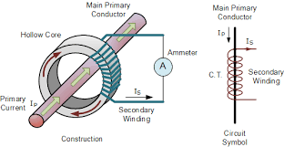

Fig 3.2 Current transformer

3.LCD display:

We have used 16*2 ,5*7 dot matrix lcd to continuously display power factor of the load.We have connected the datapins to Port D and control pins to Port E.

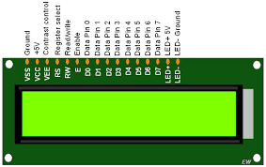

Fig 3.3 LCD display.

4.OP-AMP LM324:

We need to convert sinusoidal o/p of transformers into square wave, which is why we decided to use LM324 .We are using it as a zero crossing detector.

We chose LM324 over LM358 because the operating voltage of LM324 is 5V.Hence ,it was not necessary to use another power supply.

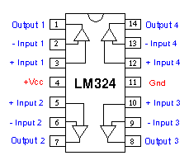

Fig 3.4 Op-amp LM324

5.ULN2003:

Output of PIC 18 is not compatible with relay .Hence ,we are using ULN2003 as a relay driver to operate the relays. It consists of 7 darlington pairs and acts as a current booster.

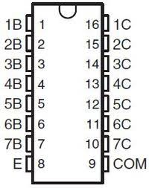

Fig.3.5 Relay Driver.

6.Relay:

We are using 5V relay as a switch to connect the shunt capacitors to the load. The relays provide an isolation between the PIC18 and 230V ac mains supply.

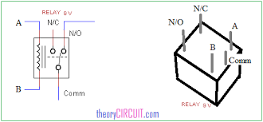

Fig 3.6 Relay

7. Microcontroller:

We are using PIC 18f4550 microcontroller because programming in Embedded C is easier and more efficient as compared to assembly language processor in the case of 8051 microcontroller. ARM processors are costlier.

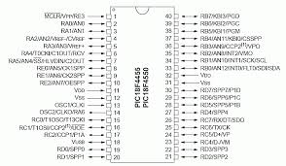

Fig.3.7 Microcontroller.

8.Capacitor bank:

To correct power factor we need to connect capacitors in parallel to the load.We used power type capacitors because we are dealing with high power ac mains.

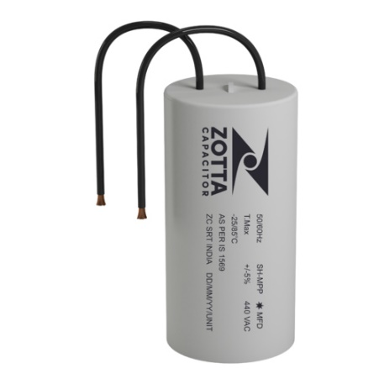

Fig 3.8 Power Capacitors

Calculations:

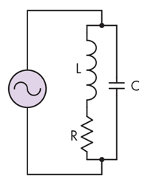

Fig 3.9 Circuit Diagram

**CHAPTER 4**

Design and Implementation

ELECTRONICS AND HARDWARE DESIGN ASPECTS

**PIC SELCTION:**

|  |  |  |  |
| --- | --- | --- | --- |
| **Parameter** | **PIC16F688** | **PIC18F452** | **PIC18F4520** |
| **Pin Count** | 14 | 40 | 28/40/44 |
| **Operating voltage** | 2V – 5.5V | 2V – 5.5V | 2V – 5.5V |
| **Operating frequency** | 0 to 20MHz | 0 to 20MHz | 0 to 40MHz |
| **Inbuilt ADC** | 8 | 8 | 13 |
| **ADC bits** | 10 | 10 | 10 |
| **No of timers (8/16)** | 1/1 | 3 | 1/3 |
| **Program Memory** | 4K | 32K | 32K |
| **Data memory** | 256(SRAM),256(EEPROM) | 368(SRAM),256(EEPROM) | 1536(SRAM),256(EEPROM) |

Table: 4.1

From this comparison we are selecting the PIC 18F452 as our microcontroller as it

is satisfying our project requirements such as high pin count, data memory.

**RESET CIRCUIT:**

We are connecting an RC circuit to the MCLR (pin1) of the microcontroller (18f452). The resistor and the capacitors values from the datasheet are 1kohm and 10uF respectively. The resistor capacitor combination gives the RC time delay for the microcontroller for it to operate properly. The PIC has an active low reset, the capacitor initially at 0V charges via the supply through a –ohm resistance in series. Therefore, the reset time of our circuit is:

R*C=1K*0.1*10^-6=0.1msec

**CRYSTAL CIRCUIT:**

Here we are connecting two capacitors which are basically of values 22pF each. In other words to give a pure square wave to the microcontroller. Basic rule for placing the crystal on the board is that it should be as close as possible to avoid any interference in the clock.

**DESIGN OF THE STEP DOWN TRANSFORMER**

To convert the input 230V to 16V and also to electrically isolate the circuit from mains, we have to require the step down transformer.

Voltage at output of the transformer,

VO= VoREG + VDROP(IC)

= 12+ 3

= 15

Turns ratio = VI N / VO

= 230 /15

So we are selecting230 -15v and 1amp secondary output transformer

**SOFTWARE ASPECTS**

PROTEUS:

It is software for microprocessor simulation, schematic capture. It is developed by

Lab-center electronics. The Proteus design suite includes schematic capture tool with the

Possibility to simulate programmable ICs like Microchip PIC, Atmel AVR etc. ARES for PCB layouts.

MPLAB: MPLAB is a proprietary freeware integrated development environment for the development of embedded applications on PIC and dsPIC microcontrollers, and is developed by Microchip Technology.

CIRCUIT DIAGRAM:

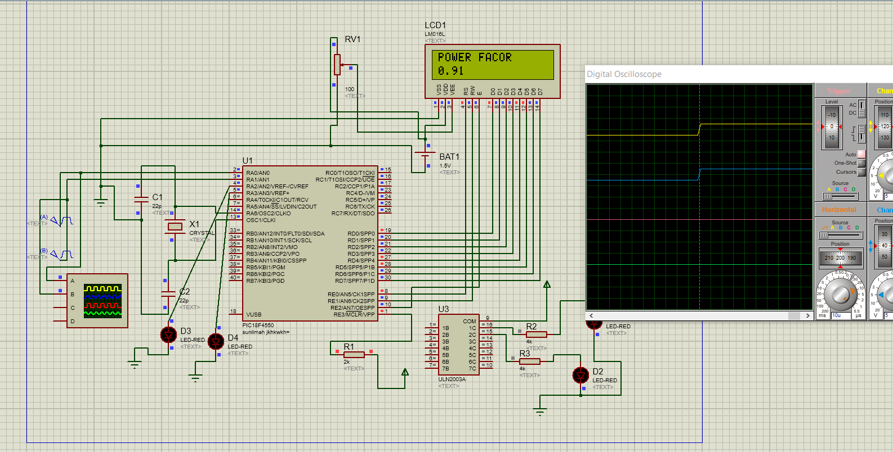

Fig. No.4.1 Proteus Schematic

In order to design the printed circuit board for our circuit we have used Altium Software.

There are total 3 separately printed circuit board:

1. Pic microcontroller

2. Power supply +5v and +12v and -12V

The main intension behind designing 3 different printed circuit board instead of one whole giant printed circuit board is getting advantage of debugging with ease .all three printed circuit boards are single sided printed circuit boards this is main reason of reducing of total cost of our project.

**1)RULES FOR MICROCONTROLLER BOARD:**

Track width =30 trace

Layer=bottom layer

Hole size=0.45mm

PCB size=15*10cm

**TESTING OF MODULES:**

**PCB AND SOLDERING TEST:**

We checked the PCB tracks for continuity and track layers. After soldering

The components we checked if there is any short circuit scenario.

**LCD:**

LCD can also be used in a project to check the output of different modules interfaced with microcontroller. Thus LCD plays a vital role in a project to see the output

And to debug the system module wise in case of system failure in order to rectify the

Problem.

**MICROCONTROLLER BOARD TETING:**

We checked the PCB for continuity. Then we checked the voltages at point VDD, VCC, and 3rd pin of 7805 and MCLR pin. We checked for reset circuitry is it working properly

Or not? Also we programmed microcontroller with test program which blinks the test led on E port. We checked the LCD, test program on PIC board.

**TEST POINTS:**

|  |  |  |
| --- | --- | --- |
| **SR no** | **TEST POINT** | **VOLTAGE** |
| **1.** | MCLR | **5V(working)&0v(reset)** |
| **2.** | PIN 11,32 OF PIC18F4550 | **5V** |
| **3.** | PIN 12,31 OF PIC 18F4550 | **0V** |
| **4.** | Transformer primary winding | **230V** |
| **5.** | Transformer secondary winding | **9V & 15V** |
| **6.** | Comparator output:  LM324 | **5V** |
| **7.** | ULN2003 pins  Pin 1c  Pin 2c | **Initially ,5V**  **0v**  **0v** |

Table: 4.2

**CABINET DESIGN AND ASSEMBLY**

The cabinet mainly consists of the following elements:

1) Batteries

2) LCD

3) Main PCB

4)Sensing Elements i.e. Potential and current transformer.

5) Adapter

6)Load

**PCB DESIGN:**

* 1. **MAIN PCB (BOTTOM)**

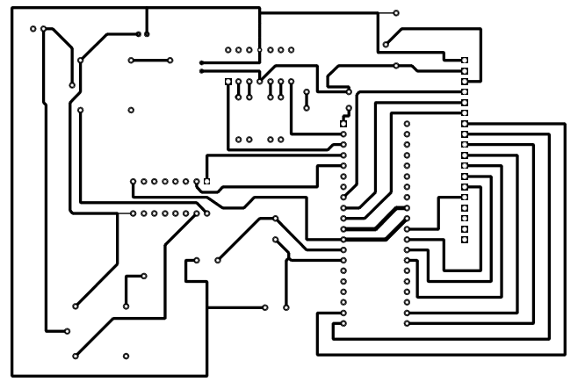

Fig No.4.2 PCB layout

Breadboard Implementation:



Fig. No.4.3 Breadboard connection

**CHAPTER 5**



Fig No.5.1 DSO output

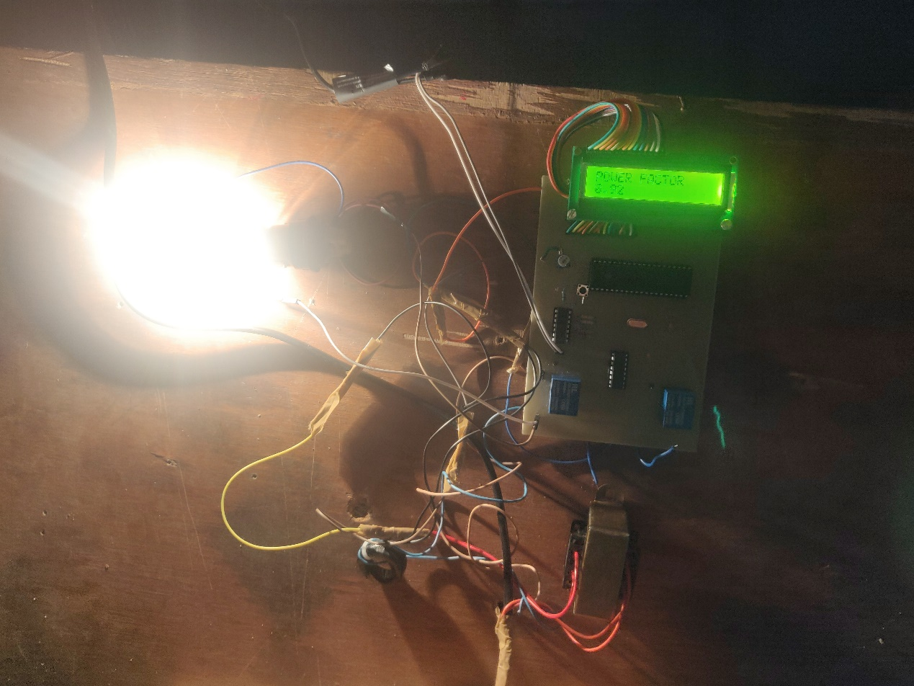

Fig No.5.2 Project Setup

Results:

By observing all the above aspects of the power factor it is clear that power factor is the most important part for the utility company as well as for the consumers. Utility companies will be free from the power losses as well as the consumers are free from low power factor penalty charges.

|  |  |  |
| --- | --- | --- |
| **Load** | **Power factor** | **Relay status** |
| Resistive | 0.92 | Off |
| Inductive | 0.66-0.8 | On |

Table: 5.1

Potential Transformer Output:

|  |  |
| --- | --- |
| **Voltage** | **Frequency** |
| 12.6 V (AC) | 50Hz |

Table: 5.2

Current Transformer Output:

|  |  |
| --- | --- |
| **Voltage** | **Frequency** |
| 1.1V (AC) | 50Hz |

Table: 5.3

Conclusion and future Scope:

The Power Factor is improved by installing suitably sized power capacitors into the circuit thus line losses are improved and the efficiency of a plant increases . By using this system the efficiency of the system is highly improved. Precautions should be taken for over correction otherwise the voltage and current increases due to which the power system or machine will not remain stable and the life of capacitor bank decreases.

The automatic power factor correction by using capacitive load banks is very efficient as it decreases the cost by reducing the power drawn from the supply. As it operates automatically, no manpower is required and this Automated Power factor Correction by using capacitive load banks can be used for the industries purpose in the future. Further the project can be intensify by using thyristor control switches in place of relay control so that contact pitting is avoided which is often resulted by switching of capacitors due to flow of high in rush curve.

**BILL OF MATERIAL USED**

|  |  |  |
| --- | --- | --- |
| **SR. NO.** | **COMPONENTS** | **Prices** |
| 1 | LM 324 | 8 |
| 2 | Power Transformer | 150 |
| 3 | Current Transformer | 50 |
| 4 | Power capacitor(2) | 40 |
| 3. | Relay(2) | 50 |
| 4. | ULN2003 | 18 |
| 5. | Resistors | 5 |
| 6. | LCD | 160 |
| 7. | Bulb | 20 |
| 8. | Choke | 220 |
| 9. | Connecting wires (female to female) | 50 |
| 10. | PIC18f4550 | 300 |
| 11. | Multistrand wires | 20 |
| 12. | Connecting wires (male to female) | 50 |
| 13. | Push button | 4 |
| 14. | Crystal(20MHz) | 20 |
| 15. | Capacitors(2) | 20 |
| 16. | IC bases | 30 |
| 17. | Adapter | 150 |
| 18. | Other Expenses | 50 |
| 19. | Potentiometer | 4 |
| 20. | PCB | 330 |
| 21 | Burg strips | 50 |
|  | Total cost | 1799 |

Table: 3.2

**REFERENCES:**

1.en.wikipedia.org/wiki/Power_factor_correction.

2.”Energy Saver power Factor Controller For Synchronous Motors”.IEEE

Transactions on Power Apparatus And Systems.

3.Jos Arrillaga,”Power System Harmonics “.

4.”Power Factor Technical “ available at [www.researchgate.com](http://www.researchgate.com).

5.Minimizing Penalty In Industrial Power Consumption By IRJET.

https://www.irjet.net/archives/V4/i3/IRJET-V4I3366.pdf.